**Lab 5.1.3**

Kale Dunlap

11/27/2023

Part C: Payload created using msfvenom

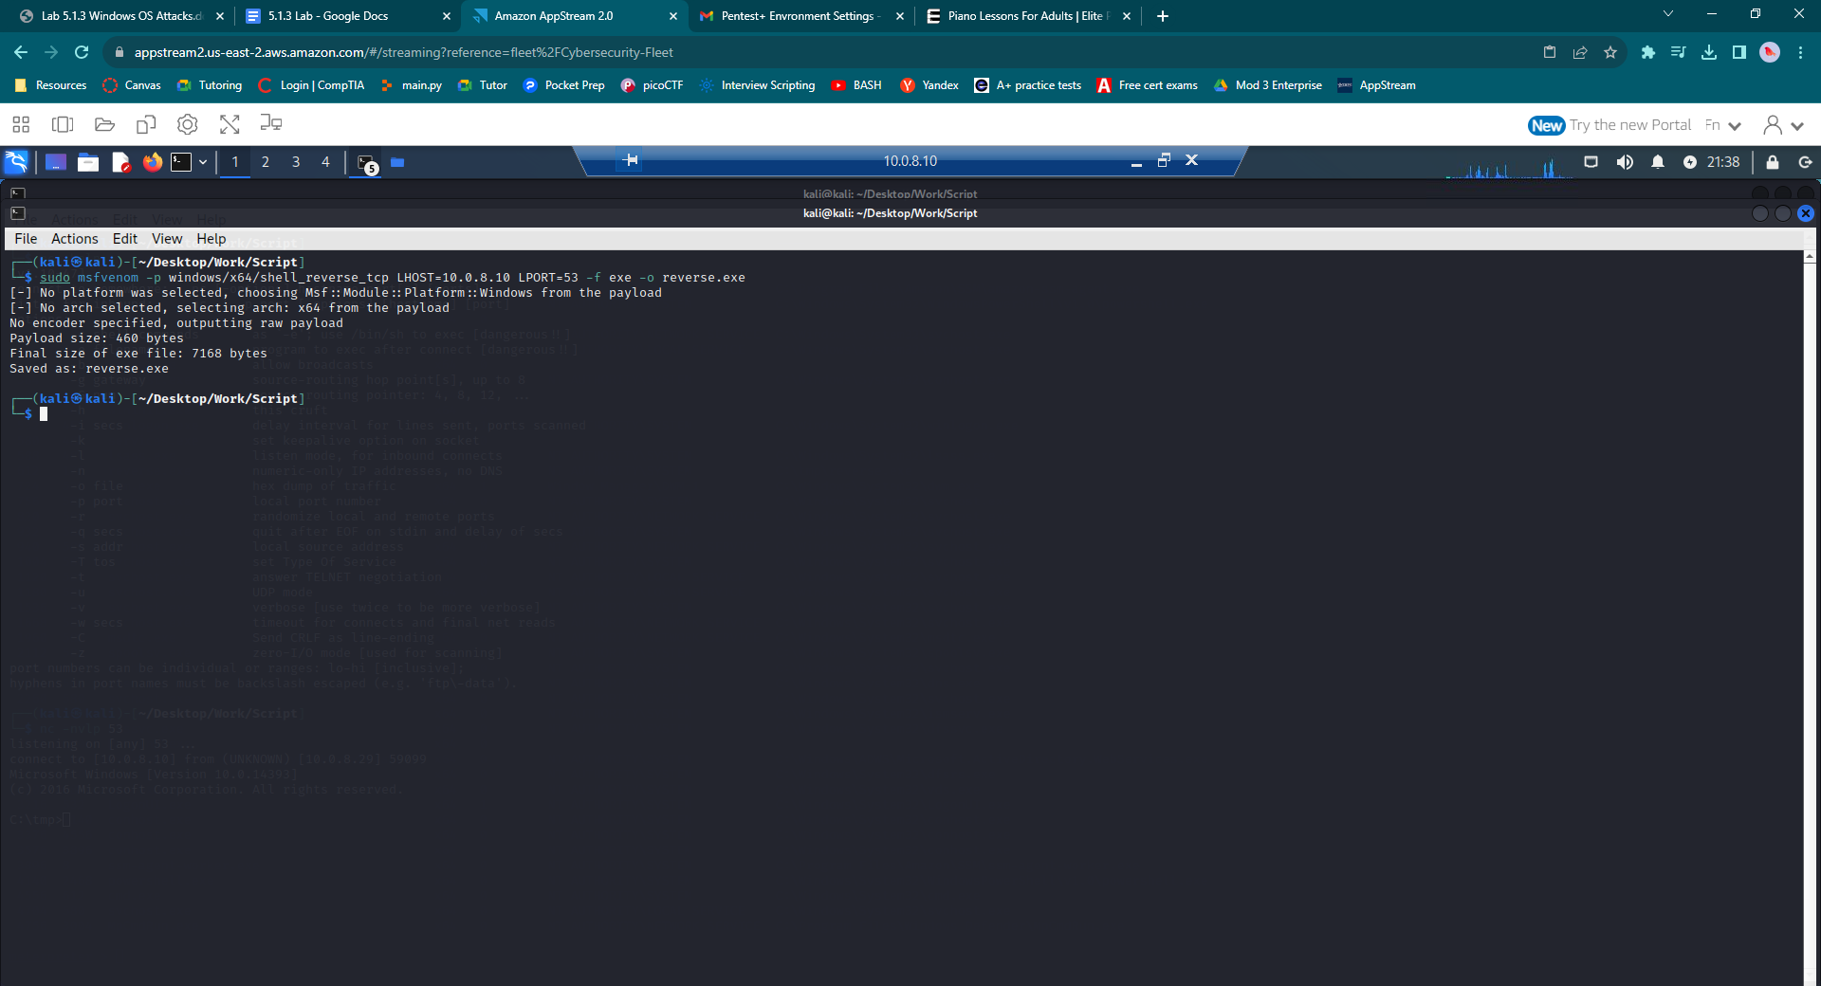

Part D: Top-Secret-WWilson copied to Kali

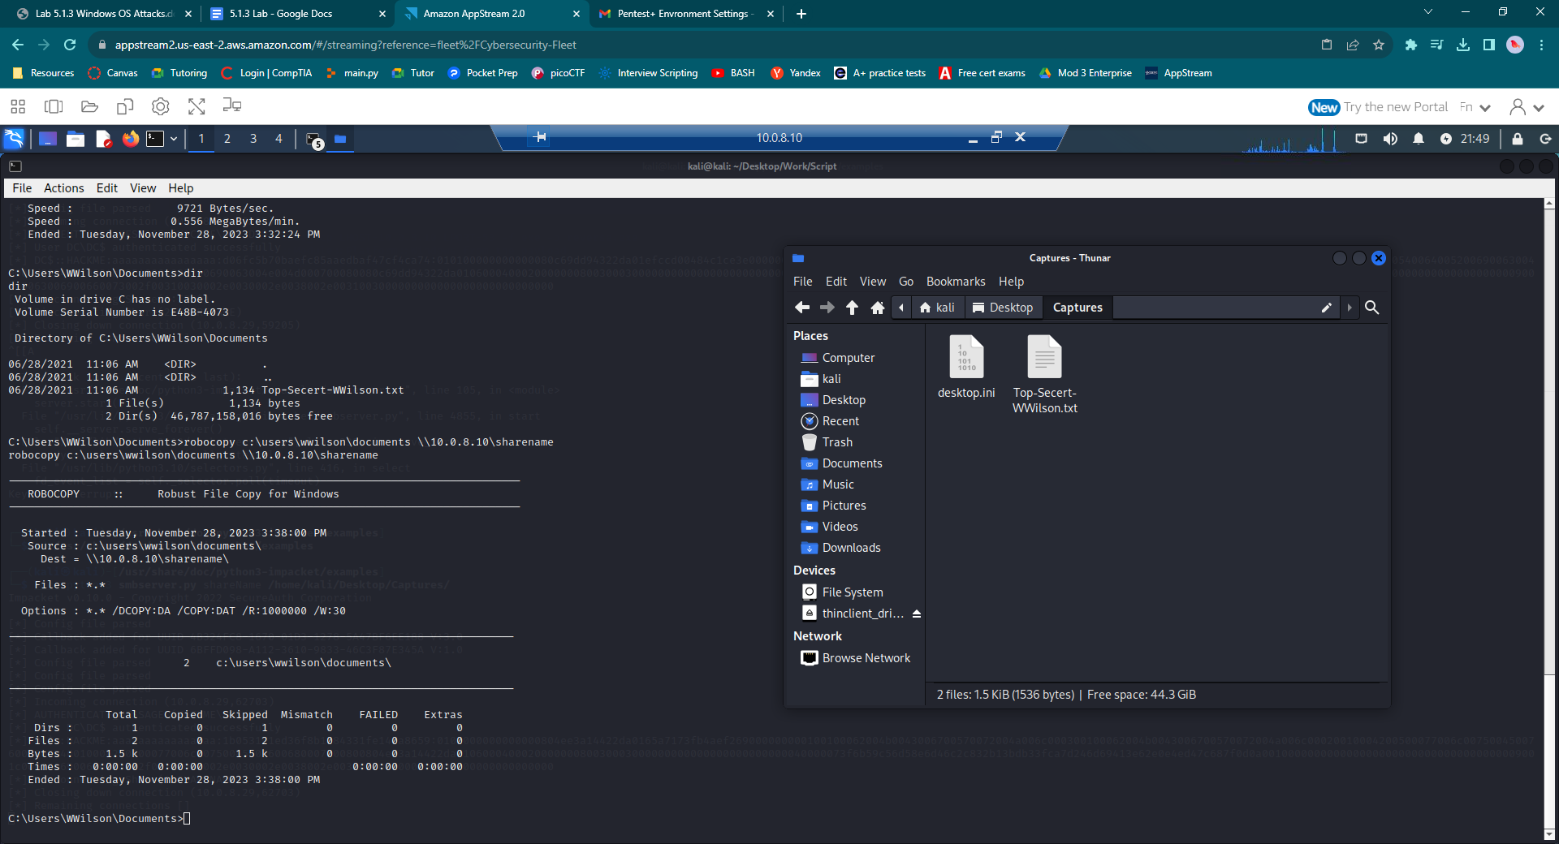

Part E: ValueError: not enough values to unpack

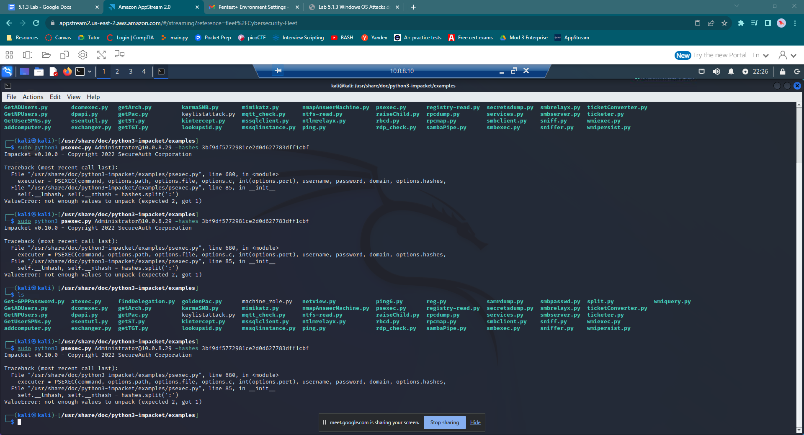

Part F: unable to continue due to the error encountered in Part E

